CSR BINGO CSR ACK 1st

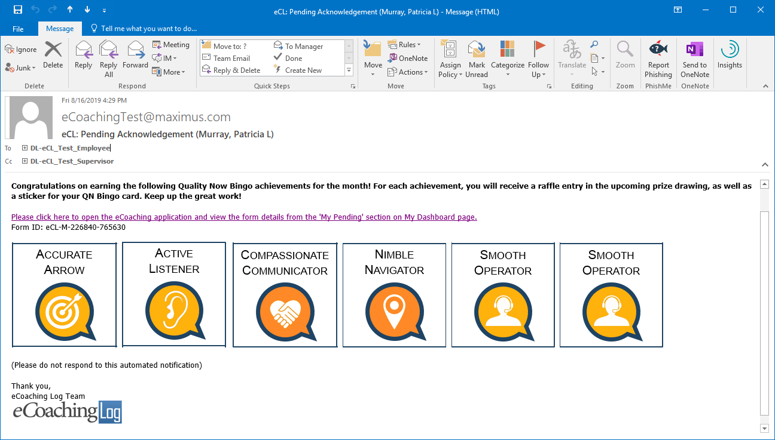

CSR Pending ACK

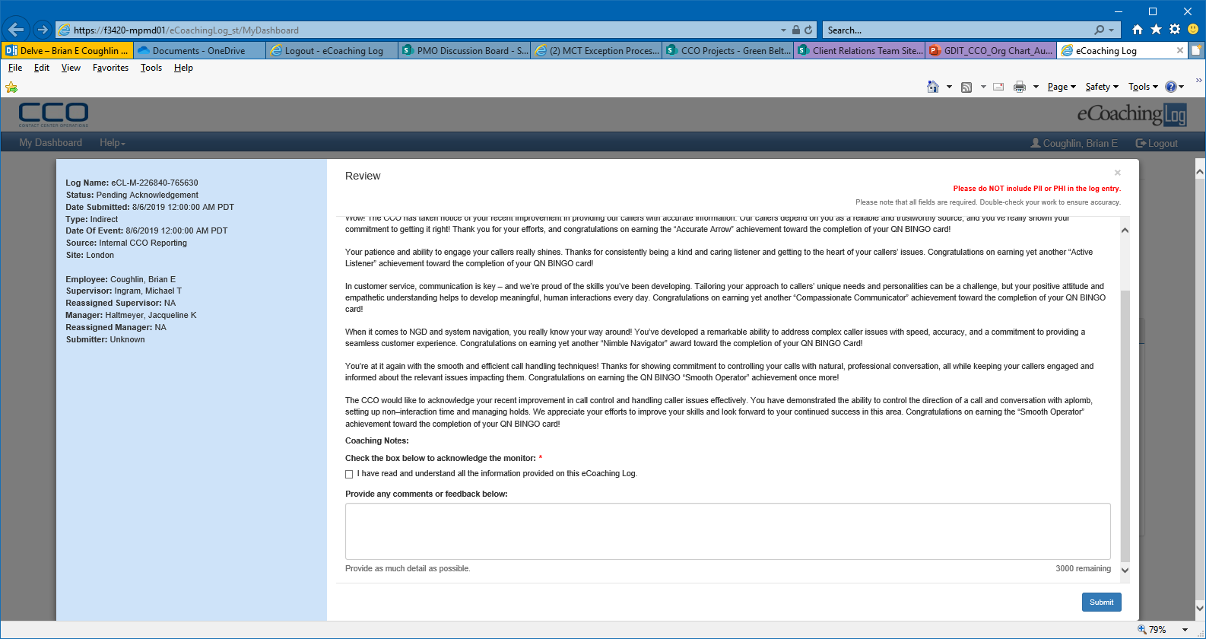

Pending Sup Review

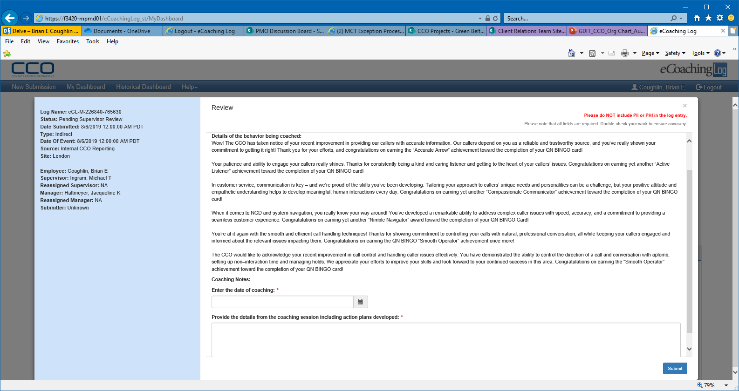

Pending CSR Review

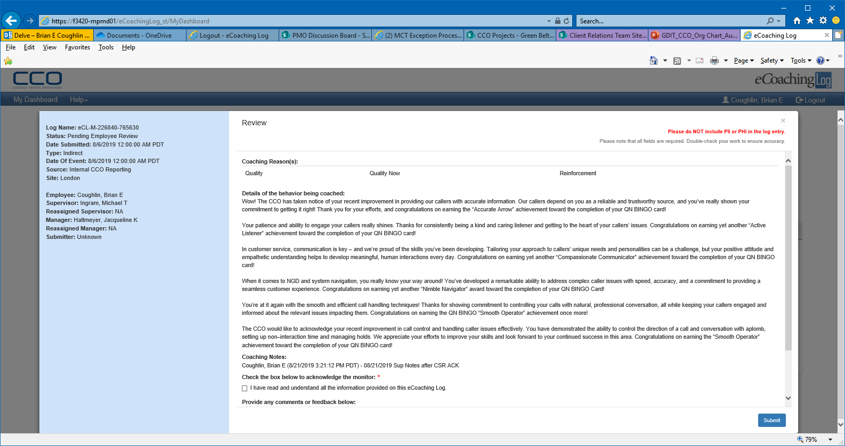

Completed

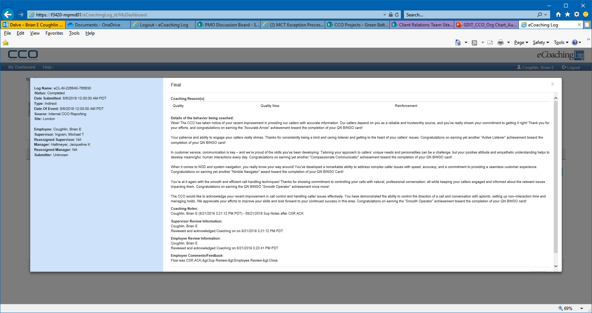

Completed email

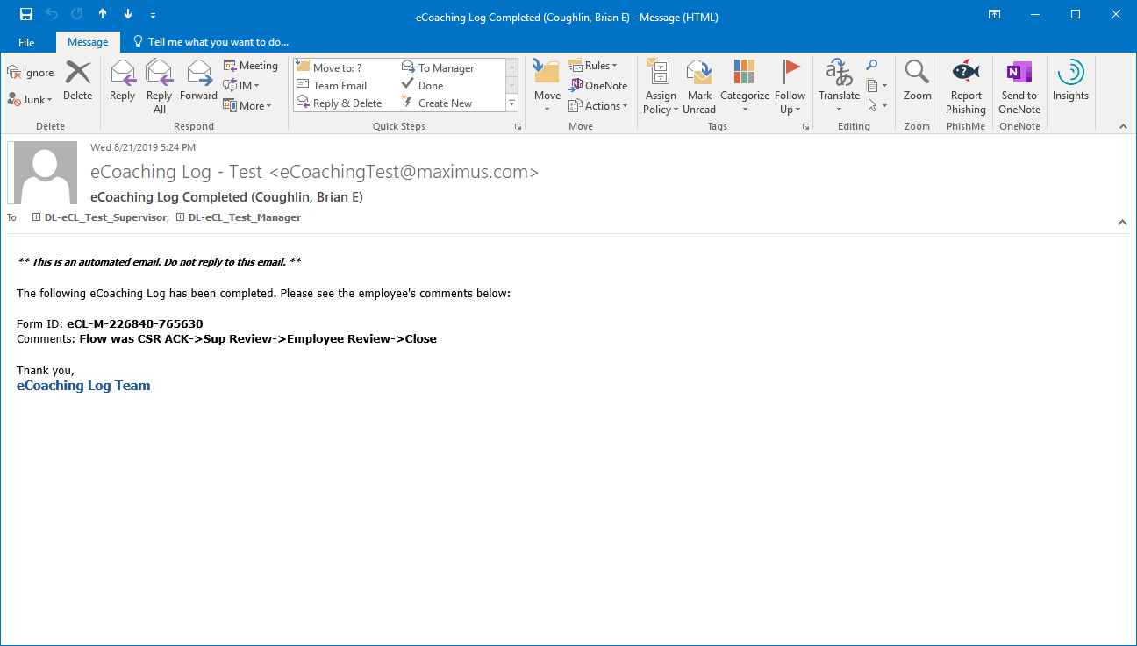

____________________________________________________________________________________

CSR BINGO Sup ACK 1st

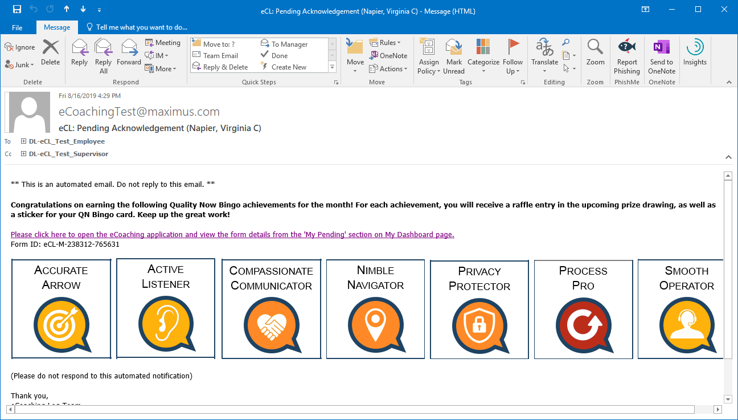

Sup Pending ACK

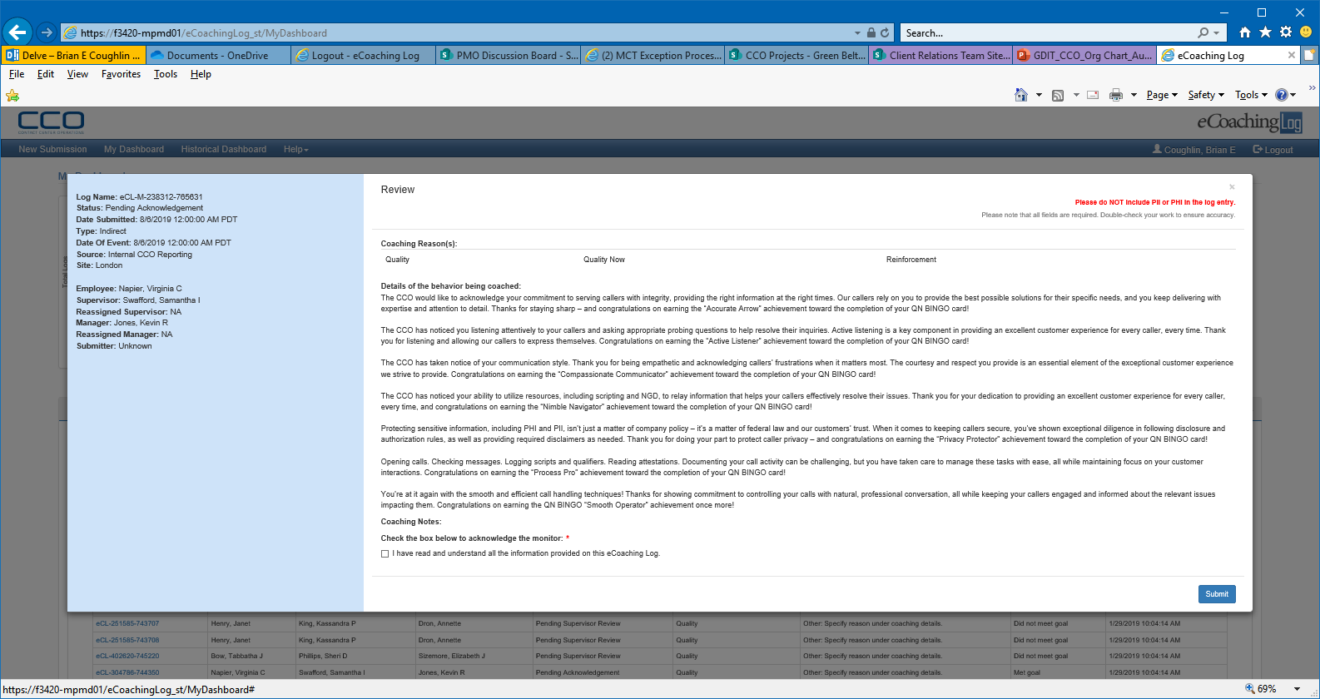

Pending CSR Review

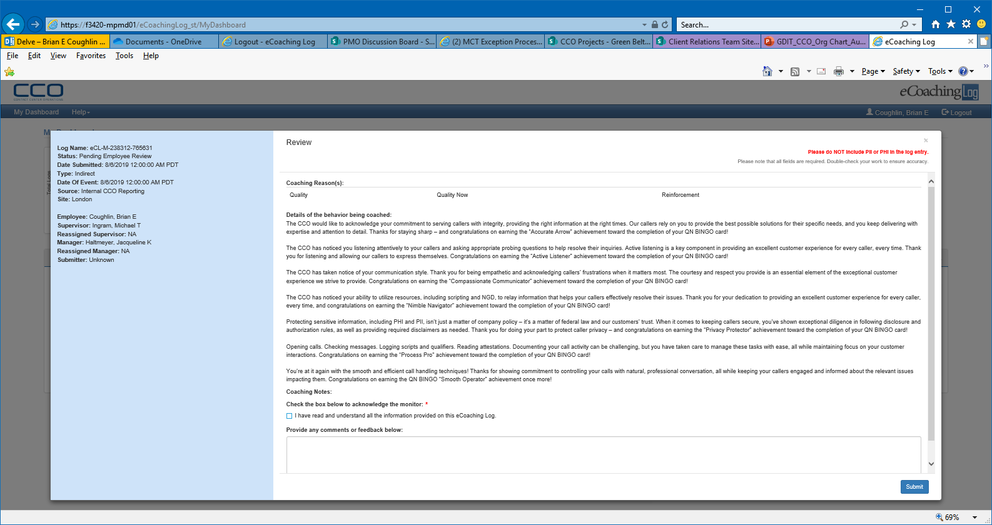

Completed

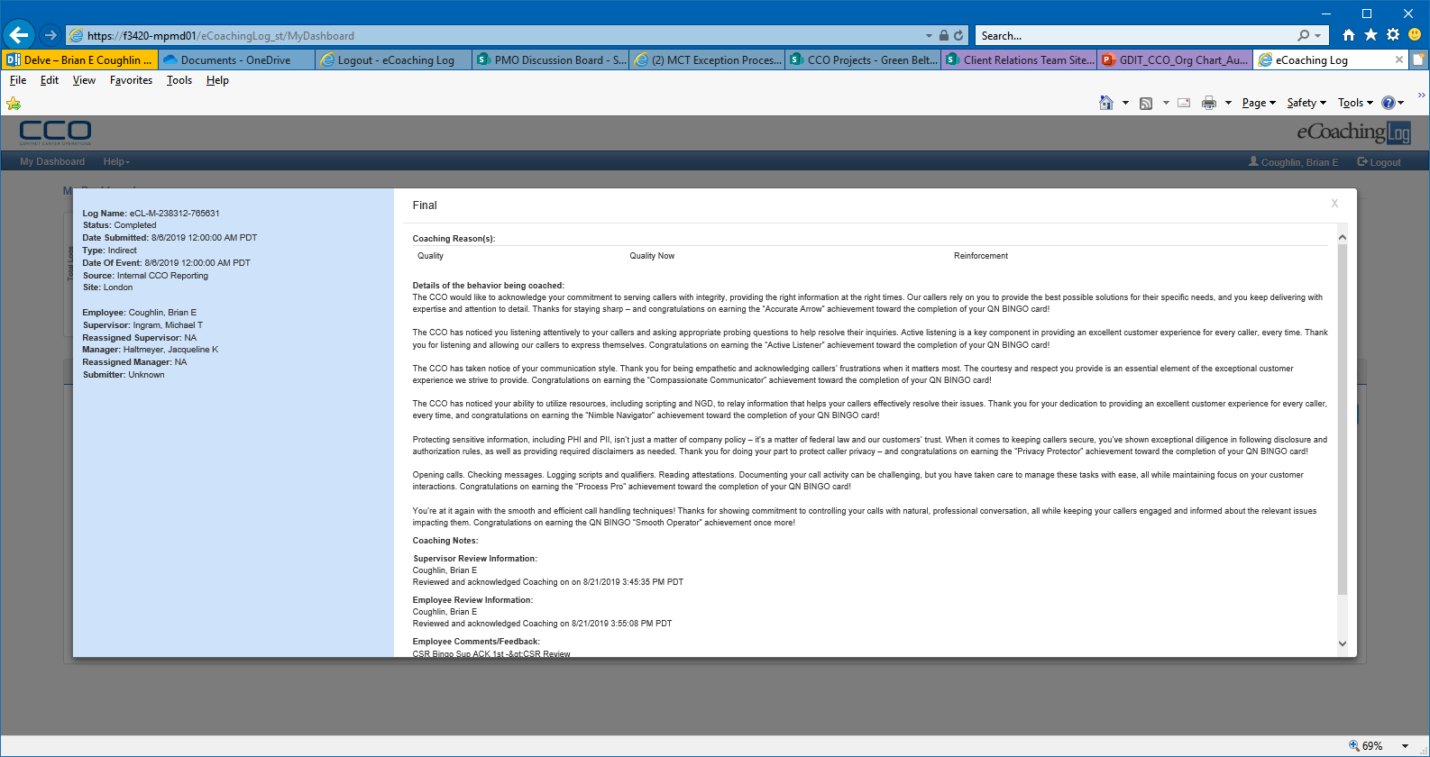

Completed email

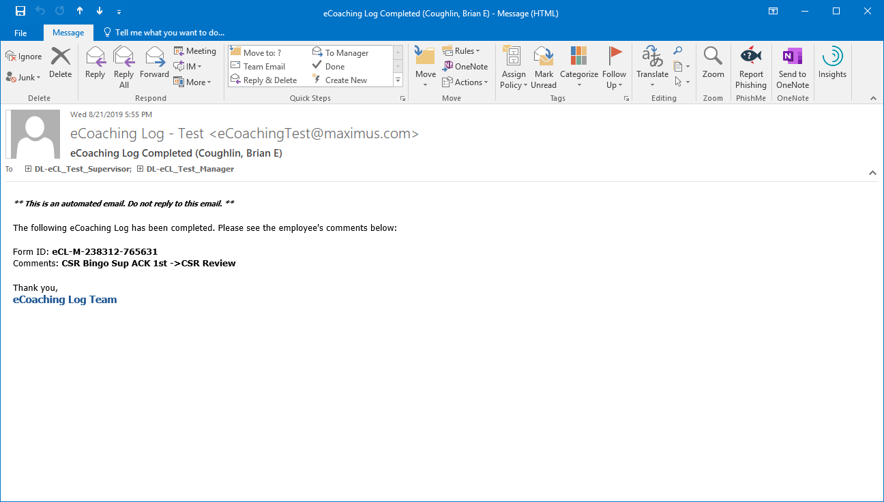

_____________________________________________________________________________________

Sup Bingo Sup ACK (Didn’t get Completed email)

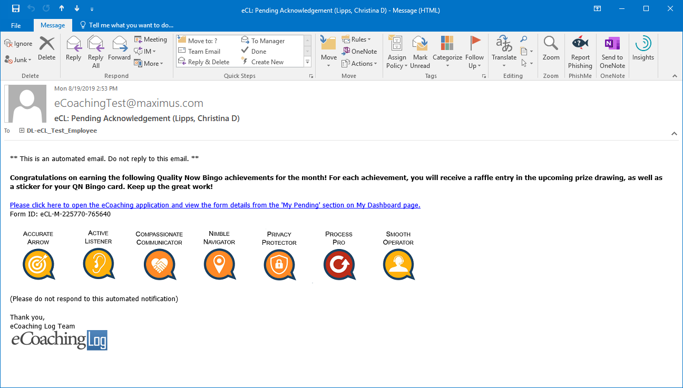

Sup Pending ACK

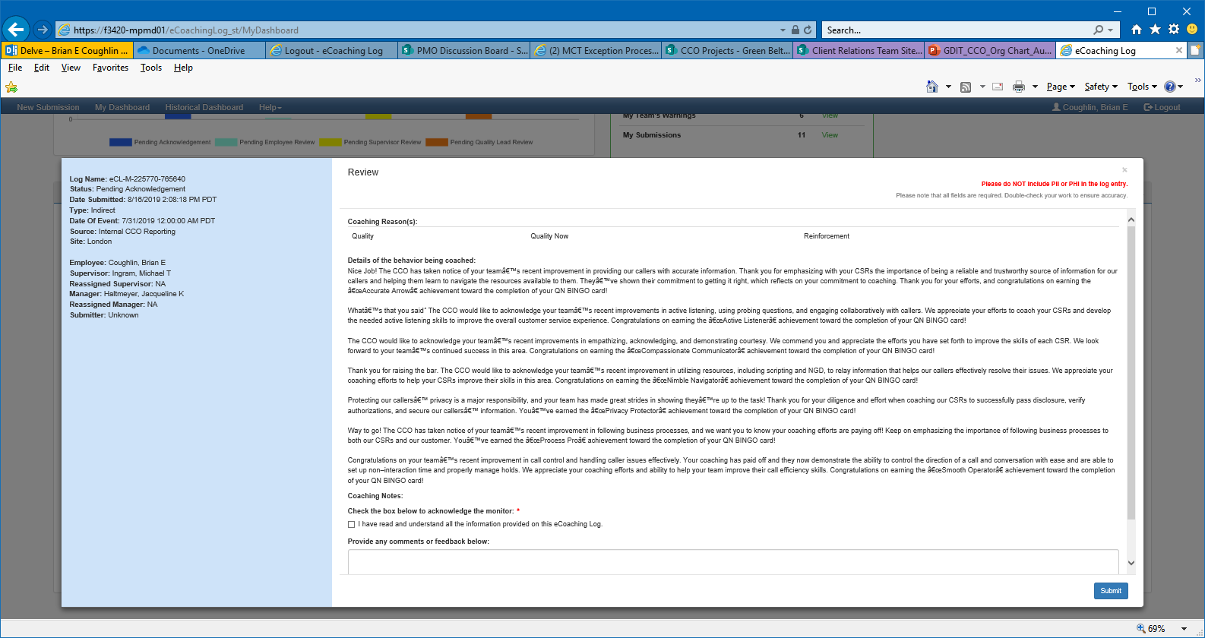

Completed

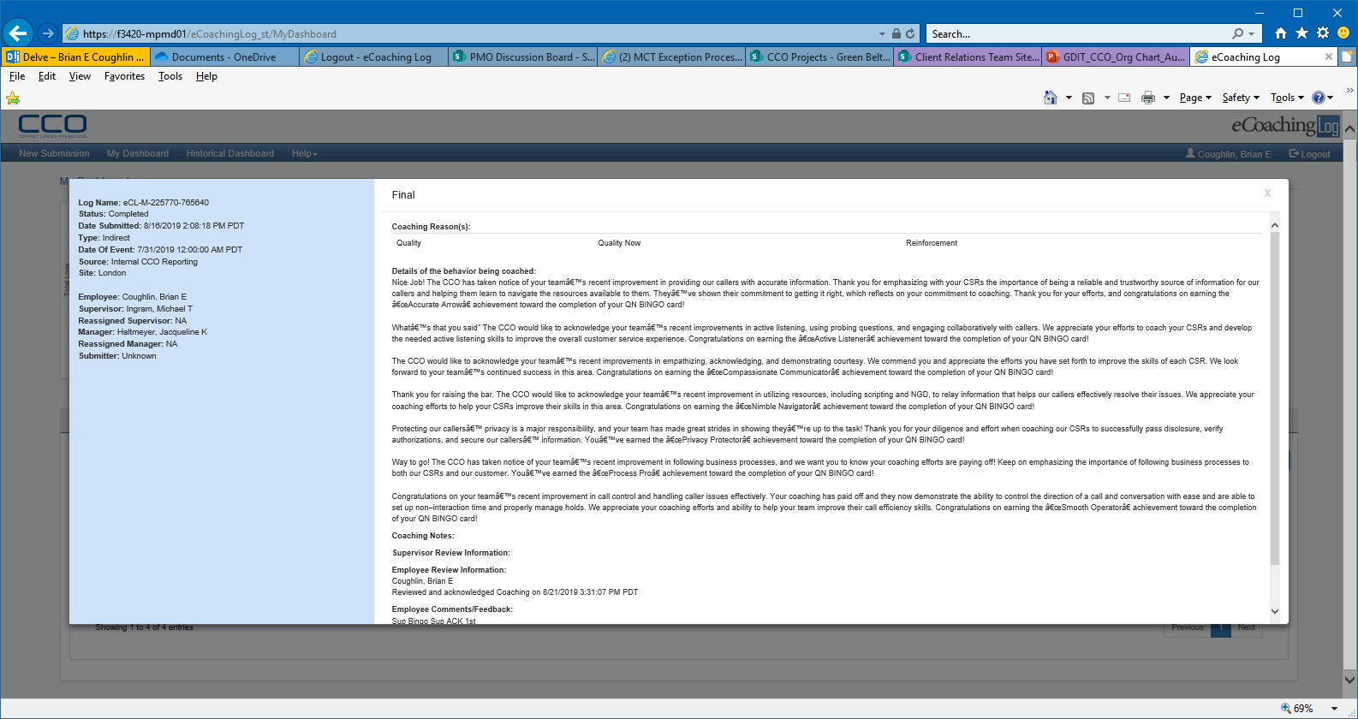

_____________________________________________________________________________________

Mgr Level Sup Bingo

Sup Pending ACK (Didn’t get Completed email)

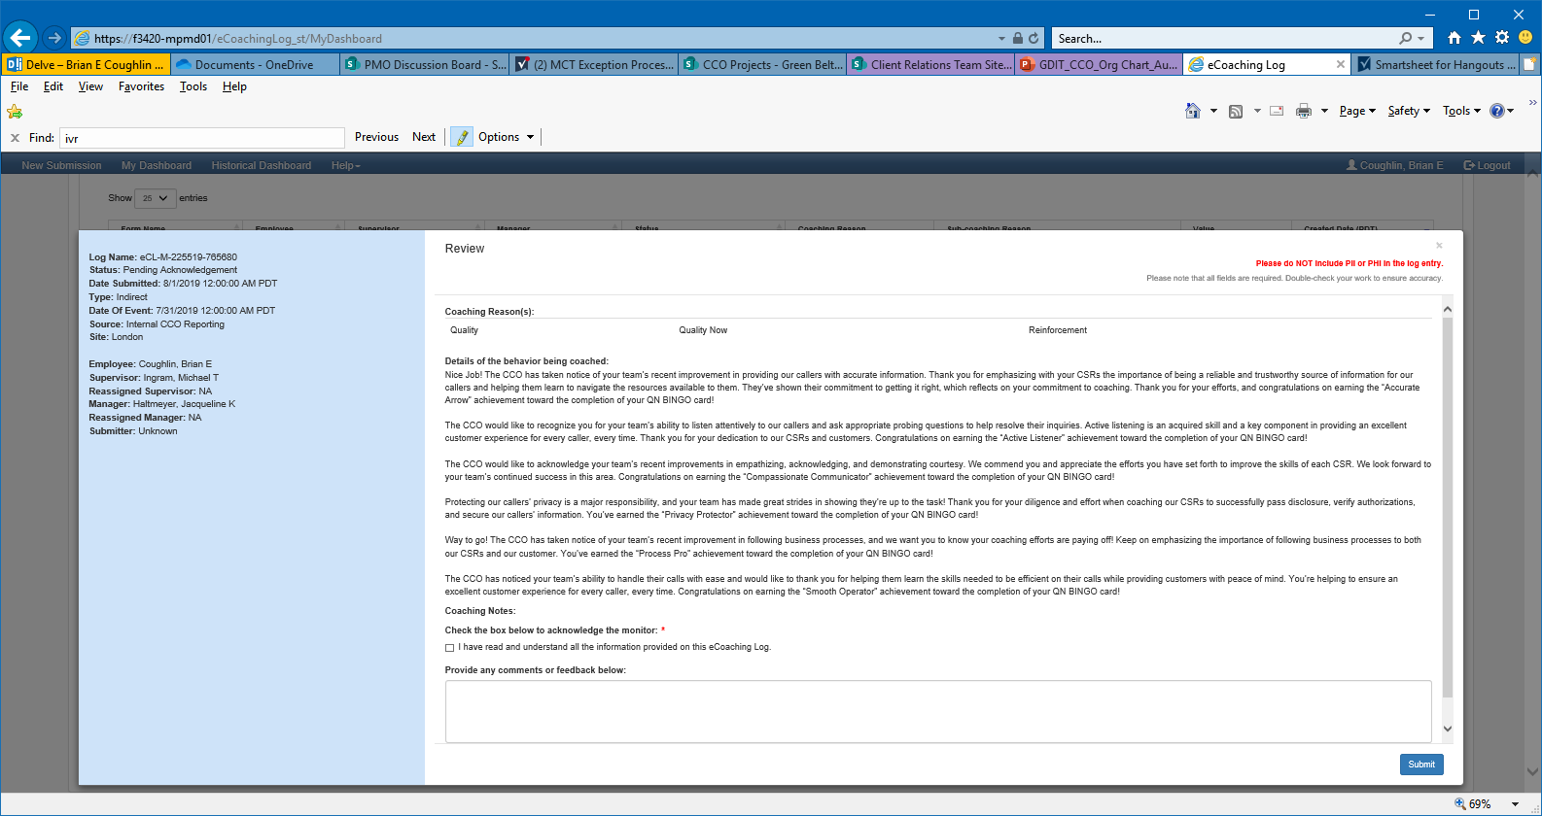

Completed

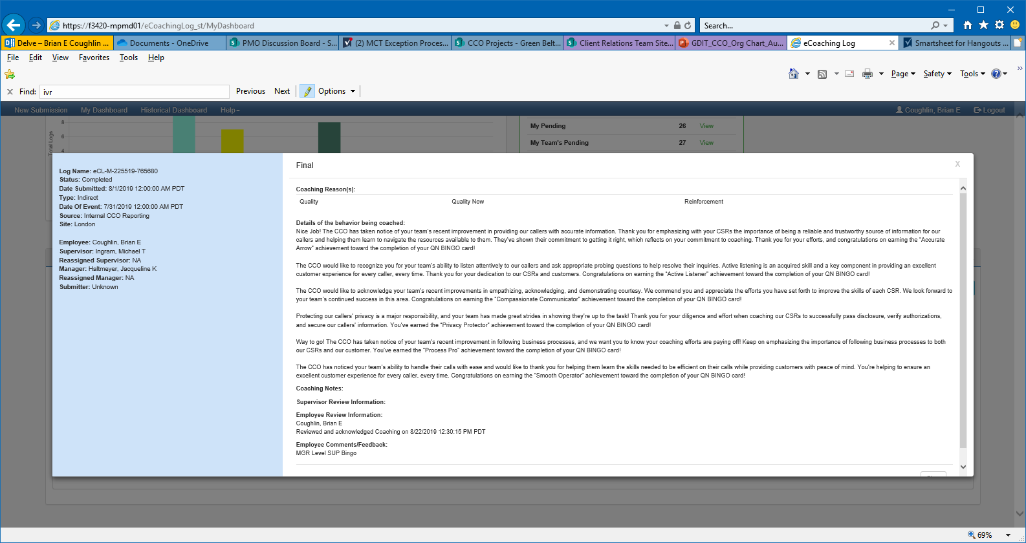

All Possible Achievement Messages

|  |  |  |  |
| --- | --- | --- | --- |
| **Achievement** (Coaching IDs) | **CSR Visibility Language – MAINTAINS** | **CSR Visibility Language – IMPROVES** | **CSR Visibility Language – IMPROVES Beyond Effective** |
| Nimble Navigator | Sup 765675 CSR 765686 | Sup 765671 CSR 765629 | Sup 765688 CSR 765687 |
| Smooth Operator | Sup 765671 CSR 765629 | Sup 765675 CSR 765687 | Sup 765688 CSR 765687 |
| Active Listener | Sup 765671 CSR 765686 | Sup 765675 CSR 765629 | Sup 765688 CSR 765687 |
| Compassionate Communicator | Sup 765662 CSR 765686 | Sup 765679 CSR 765629 | Sup 765688 CSR 765687 |
| Process Pro | Sup 765662 CSR 765686 | Sup 765675 CSR 765629 | X |
| Accurate Arrow | Sup 765676 CSR 765686 | Sup 765675 CSR 765629 | X |
| Privacy Protector | Sup 765662 CSR 765686 | Sup 765675 CSR 765629 | X |